- Chapter 2: The river corridor is a significant reservoir for stream carbon
- Introduction
- Riparian wetlands, the transitional zone between terrestrial uplands and streams, assumes a disproportionate influence on stream chemistry as all terrestrial particulates and nutrients must pass through them, typically via subsurface flow, before discharging into streams (Kirk & Cohen, 2023; Wohl et al., 2017). Riparian groundwater and soils assume a prominent role in stream carbon cycling with both riparian groundwater and soil water DOC and CO2 concentrations tremendously higher than stream concentrations.
- The river corridor (RC)- the stream, the hyporheic zone, and the carbon-rich riparian wetland from water table to canopy- serves as the primary pathway for lateral carbon exchange between terrestrial uplands and streams (Kirk, 2023; Ledesma et al., 2015, 2018).
- Encompassing bp the riparian wetland and hypopheric zone,

- The zone of lateral exchange between streams and adjacent uplands is commonly referred to as the river corridor (RC), encompassing the stream, the hyporheic zone, and the carbon-rich riparian wetland, from water table to canopy (Harvey & Gooseff, 2015; Kirk & Cohen, 2023).

- As a result, riparian wetlands have been hypothesized to harbor a significant potential for carbon storage and serve as significant carbon source for streams (Ledesma et al., 2015), especially if the landscape favors subsurface lateral flow (Harvey & Gooseff, 2015; Kirk & Cohen, 2023).

- The RC is hypothesized to contain disproportionately high concentrations of both inorganic carbon (IC) and organic carbon (OC), in gaseous and particulate phases, and serves as the primary pathway for lateral carbon exchange between terrestrial uplands and streams (Kirk, 2023; Ledesma et al., 2015, 2018).

- Despite their importance, the river corridor (the riparian wetland and hyporheic zone), are frequently neglected in research.
- At the global scale, distinguishing the river corridor from the terrestrial uplands, especially during baseflow, is challenging and is instead left exempt from estimates.

- At the watershed scale, in-situ measurements of riparian groundwater and stream CO2 dynamics remain scarce. studies that have investigated wetland carbon-fluxes to streams often overlook riparian wetlands, instead focusing solely on isolated or intermittently connected wetlands (those linked to streams by overland flow during periods of high discharge) (e.g. Casson et al., 2019; Hosen et al., 2018; Moustapha et al., 2022; Solano et al., 2024). As a result, the influene of hydrological settings on temporal stream carbon is poorly understood. In boreal forests, studies have shown that up to 90% of stream dissolved organic carbon (DOC) is derived from the RC, which maintains a long-lasting supply of DOC with a theoretical turnover time of hundreds of years (Ledesma et al., 2015, 2018).
- Kirk and Cohen (2023) found that 86% of the lower Santa Fe River's CO2 originated from its RC, with only 14% sourced from groundwater seepage.
- SOURCE found isolated and intermittently connected wetlands only contributed a relatively minor 15% of carbon to stream C and surmised the remainder is sourced from the RC.

- An ecosystem garnering increasing interest for its capacity to store carbon in RCs is the flatwoods of North Florida.
- Due to the flatwoods confined aquifer and dense wetland-area, deep groundwater seepage is negligible, and the flux of carbon to streams is primarily driven by lateral transport via the shallow water table
- While groundwater seepage may account for most of stream carbon in unconfined watersheds, flatwood landscapes exhibit unique modes of carbon transport that are largely disconnected from deep groundwater upwelling.
- This hydrology fosters carbon storage and creates a transport network through which nutrients and particulates flow laterally downhill before ultimately discharging into tannic, blackwater streams, emphasizing the importance of the river corridor (RC).

- For the second chapter of my dissertation, I will investigate the influence of the river corridor (RC) on stream carbon by estimating RC carbon-fluxes (DIC, DOC, and CO2) to streams at three locations spanning a gradient of wetland coverage within the flatwoods of BEF.
- In addition to field methods, by synthesizing information from the literature, the US Water Quality Portal (WQP) and the National Water Information System (NWIS), I aim to explore RC carbon transport across both confined and unconfined watersheds to broadly elucidate the RC's role in global stream carbon fluxes.
- I hypothesize (1) that the RC, the ecotone between the upland terrestrial landscape and the stream channel, delivers the majority of stream carbon and serves as a significant carbon stock in the flatwood landscape (FIGURE 2).
- Additionally, I anticipate (2) that RCs within basins with greater wetland area will exhibit a greater carbon-storage potential due to their raised water tables, supporting lateral subsurface transport, leading to higher fluxes of carbon.
- This chapter will develop a conceptual understanding of the carbon budget within flatwood landscapes and to draw insights into lateral carbon fluxes within confined and unconfined watersheds.
- From the field sampling, I aim to investigate flatwood-RC influences on stream carbon dynamics and improve flatwood carbon budgets while
- Through data query, I aim to gather data on RC influences and carbon contributions across different watershed types (confined and unconfined aquifer units) to broadly interrogate lateral carbon-transport significance.

- 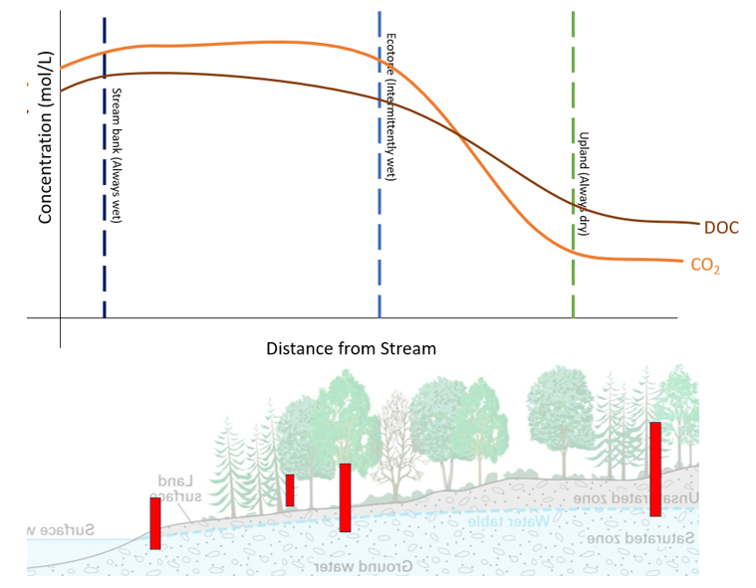
- FIGURE 2. Visual aid for hypothesis 1. Red rectangles are proposed well locations, and the above line graph hypothesizes DOC and CO2 concentrations within each well’s zone. Due to the river corridor’s (RC) tremendous carbon storage potential, as water moves laterally towards the stream, the concentration of C increases before discharging to the stream.

Methods:
Study Site:
- The BEF is a contiguous pine flatwood situated above substantial clay bed (Hawthorne Formation) that confines the principal aquifer (UFA) stretching from North Florida to South Carolina (Hensley & Cohen, 2017). Characterized by low-relief topography, the area is densely packed with depressional basin wetlands, typical of North Florida flatwoods, and supports a substantial lateral transport network.
- For this chapter, I will observe three river corridors (RCs) from stream 5, 6, and 9. Each of these streams belong to three distinct basins, each representing a gradient of wetland-area coverage (Ref. map).

- Along with the high-frequency, long-term sensor packages from Chapter 1, groundwater wells will be strategically installed across each streams river corridor (RC), such as along the RC’s elevation gradient (stream bank, upland, and in-between) and any significant micro-landscapes (intermittent flow paths and depressions, if present).
- Each well was installed during the dry season to ensure the shallow water table could be reached even when the stream bed was dry. Often, wells were installed to the point of collapse due to saturated soil (6-10 meters).
- None the less, wells often dried out, or did not adequate volumes for samples, during the driest periods of the year. However, at least one well from each site had a viable volume of water present.

- Prior to sampling, at least triple the volume of the well will be removed. If well water is exhausted during this process, the well will be deemed dry.
- During each monthly field visit, a roving pH (HOBO) and CO2 sensor (K30 10%) will take point readings of groundwater quality. Additionally, water table depth will be measured using a water level meter (NAME).
- Well water was excavated using a peristaltic pump, filtered with filter capsule, and collected for DIC, DOC, and fluorescent dissolved organic matter (FDOM). During periods of high discharge, when intermittent flows paths and micro-wetland depressions are present, FDOM, DIC, and DOC samples will be taken from these locations.
Sample Processing
- Both DIC and DOC analysis will be conducted using the Shimadzu TOC-L analyzer utilizing the TOC (total organic carbon) Measurement method.
- DIC is notoriously challenging to analyze as it has the potential to quickly degas from the sample, underestimating DIC concentrations. To minimize error, acid-washed Shimadzu sample-vials were used in the field to sample DIC, avoiding any potential degassing that could occur when decanting for analysis. In the field, vials were filled to maximum capacity to deter head-space equilibration. Post-field day, all samples were stored in the fridge and analyzed within the next 48 hours.
- For quality control, DIC will also be interpolated using the pH, temperature, and CO2 point readings, and samples were periodically analyzed for alkalinity.
- FDOM samples will analyzed following the protocols outlined in Chapter 1. The pH sensor was calibrated prior to each field day and all sampling equipment (syringes, vials, and bottles were acid washed.
Discharge Estimates
- The estimation of RC lateral discharge will use methods adapted from Kirk and Cohen (2020) and involves applying concepts and filtering techniques from Kalbus et al. (2016) and Leopold & Maddock (1953).
- This approach utilizes mass balance principles to divide the stream’s discharge into baseflow and high discharge (surface run-off). Digital elevation model (DEM) data will be utilized to estimate the upslope contributing area (UCA), the area of land that contributes water to the site’s discharge, for each site. The interpolation of lateral discharge is achieved by multiplying the UCA by the baseflow.
Data synthesis
To compare RC influence across confined and unconfined aquifer units, available data on C concentrations (including IC and OC), discharge and DEMs from 2014 to the present will be collected from the literature and the Water Quality Portal (WQP). Sites with a minimum of ten water sample collections will be retained for analysis.
Statistical Analysis
- To assess whether RC C-contributions to stream C vary across different wetland area coverages and discharge levels, linear regression analysis will be employed to evaluate the strength of correlation.
- To test whether RC contributions significantly differ between confined and unconfined basins, analysis of variance (ANOVA) tests will be conducted.
- Utilizing wetland-carbon fluxes from Chapter 3, to assess whether RC contributes more to stream C than wetlands, another ANOVA test will be applied.
- ANOVA tests will allow for the comparison of mean carbon stream contributions between confined and unconfined basins, as well as between RC contributions and wetland contributions, providing insights into the relative importance of RC compared to wetlands in carbon budgeting.
- By employing these statistical analyses, the study aims to interrogate the factors influencing RC carbon-stream contributions and assess their significance in comparison to wetland contributions, expanding the of C dynamics within the study area.
FIGURE 3. A map depicting site locations and the surrounding landscape. The Bradford Forest tract, spanning 27,000 acres in Bradford County, Florida, encompasses a contiguous pine flatwoods landscape situated within the Hawthorne Formation. Characterized by low-relief topography, the area is densely packed with depressional basin wetlands, typical of North Florida flatwoods.

Word Bank.
- The PARAFAC model, akin to principal component analysis, will be employed to differentiate wetland, stream, and wetland C signatures, allowing estimation of upland and lowland contributions to C dynamics.

References:

